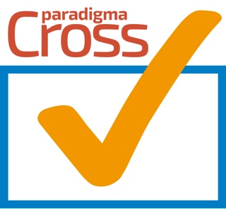

**Paradigma CrossCheck is a secure, decentralized, automatic, paperless contract monitoring (with IOT devices or not) between members, that certifies transactions helping to reduce cost and increase your business efficiency.**

**You area only three steps away from your own smart contract**

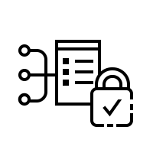

1. **Agree with business partners or team members the conditions of your contract or agreement.**
   1. **<https://media.giphy.com/media/xT9DPIlGnuHpr2yObu/giphy.gif>**
2. **Monitor your contract with Crosscheck. Check any time if the terms of the agreement have been fulfilled.**
3. 
   1. **<https://media.giphy.com/media/TYlus7VAr9c4M/giphy.gif>**
   2. **<https://media.giphy.com/media/ktYKoUcOfqRCo/giphy.gif>**
   3. **Use existing graphs to make the point!!**



1. **Get paid or pay only if conditions are met. Alternatively receive a certification or alarm according your contract.**
   1. **<https://media.giphy.com/media/3oKGzuX3WxE0KkbnTG/giphy.gif>**
   2. **<https://media.giphy.com/media/8cARKvZXq73sOZBdrw/giphy.gif>**
   3. **https://media.giphy.com/media/5n5PlOJptVMFUhFWmu/giphy.gif**

**INTRO (problem at its basis )**

Paradigma CrossCheck has been inspired by a culture of cooperation and reciprocity in small communities. Paradigma has always been at the forefront of helping communities in need for more than 20 years. On the other hand, it acknowledges from its experience that people, groups, companies and organizations have difficulties to cooperate with each other, mainly protecting their acquired knowledge, status and resources. In this reality, a decentralized economy will not necessarily develop in a natural way if people do not have the tools to do so. It is for that reason that Paradigma CrossCheck comes into life. Taking advantage of the trustless based system inherent to blockchain technology, Paradigma CrossCheck opens the possibility for anybody to develop a startup or enhance the existing business.

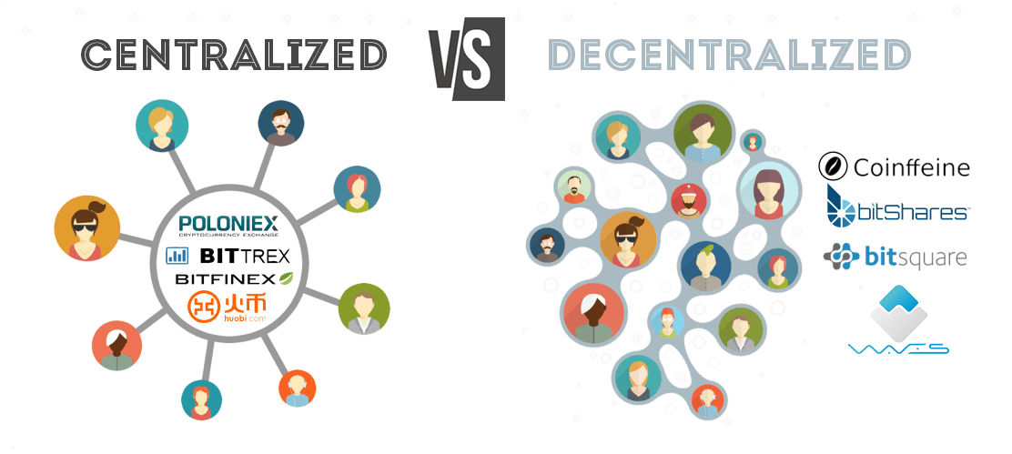

**From a centralized to a decentralized society**

A society can be seen as a stream of events in time from which some will have more impact than others. From such events, rules, procedures, legislation and a sense of what is right or wrong will guide our feelings, creating a culture around it. From within such development, organizations and institutions develop that reaffirm our status and thus creating a new way of thinking. Centralization for that matter has become an important way to organize our society. This does not mean that this is the best way forward and therefore decentralization opens a new direction. In a decentralized society less power will be centralized and will be combining both styles. We believe also that a decentralized economy can empower people, be more creative and protect better individuals and business creations and privacy.

**Providing basic tools to start decentralizing**





CrossCheck is a system for cross checking events. The cross checking of events is done by agreed procedures set in a smart contract similarly to a business legal contract. The agreed paragraphs of such a contract will start to form the basis for our own community forming a cluster of hubs and eventually a network that can stand on his own as a business. When conditions are off limit, the contract will activate and notify the parties sharing the information of such deviation. When conditions are within the agreed, business will be as usual. As per contract, information will be tracked and accumulated in a distributed manner protecting privacy. An inbuilt flexibility will allow to re-evaluate the rules that form the core of the business upon which it was created and allow to start a new line of business when needed.

A few examples:

Solving the soggy pizza problem





A pizzeria wants to deliver its products in the best conditions to his customer. For that purpose it hires an individual or company that takes the pizza to its destination. Great! How often have we had pizza delivered lukewarm, cold or soggy? Wouldn’t it be great if the restaurant, its delivery and costumer could keep track of temperature and humidity to mesuare the best conditions.

CrossCheck is a Dapp that tracks data in a ledger creating smart contracts for specific business agreements and collaborations, allowing monitoring of product conditions with IOT devices.

In this case a document is created that outlines the procedure and the right parameters of time, temperature and humidity for its delivery. Additionally a rating system can be added to the contract further deepening the understanding of what is happening.

The pizza restaurant will learn best practices and improve delivery conditions creating a network of pizzerias that provide extra quality in its delivery process.

As the system tracks delivery and satisfaction through reviews from client and incidents at transport they will be able to deliver better pizzas and be more competitive.

The client will learn from reviews the best pizza restaurant and will know which pizzerias have this quality cross-check system. It is possible that some clients will develop their own network of delivery with specific requests on their pizza altering the initial delivery contract.

New businesses could be developed too, specializing in the delivery of food.

Finally, the delivery person can track his own data and discover where you should be geopositioned to receive more delivery requests.

**Monitoring temperature at work**

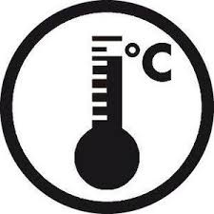

We want to track temperature in our working environment improving the office workplace environment, maintenance and or repair of equipment.

Who participates in this network and what can it do for them?:

1. The building manager renting out office space. He or she will have knowledge of the offices using more electricity than contractually agreed, enabling automatically to charge the overspending.
2. The landlord wanting to have a great and modern working space will be able to change the temperature from his phone.
3. The service and maintenance companies for the building equipment such as air conditioning will receive notification when to repair a cooling unit.

CrossCheck will enable the verification of environment parameters and automatically send a notification to all involved. As the air-conditioning temperature parameters are back to normal after 24 hours, it will automatically pay the company for its repair.

This tracking of temperature is not new. What is new is that this will happen in a secure decentralized manner, paperless and with an automatic payment system providing a certification of the events if needed.

CrossCheck is a platform for different business networks such as described above, with the extra benefit that each can be implemented with its own characteristics. Similarly to the pizza network, this cluster can be developed in any direction the market needs, altering the variables and their ranges.

**Monitoring ship containers**

**Problem: temperature can drop or rise inside a reefer container enough to damage its contents.**

Containers are being tracked with IOT devices and a bill of lading registers all the relevant information for shipping. The bill of lading will be transformed into a smart contract and the IOT device will monitor among other the temperature range acceptable for producer, carrier and buyer. Real time tracking enables to make decisions on the go avoiding in this case great potential losses. The contract will make further possible the following:

1. Tracking which carrier is moving the container.
2. Tracking where the container is located globally.
3. Tracking if the environment conditions inside the container are the correct ones.
4. Tracking if a container is being open, shaken or altered in some way.
5. Tracking if the geopositioning correspond with the timetable of location.
6. Tracking if the container needs to be brought to a different harbor due to accelerated ripening of fruit.
7. Arrange an automatic payment at arrival or arrange an automatic demurrage in case of delay.
8. Make possible a paperless documentation handover.
9. Etc. etc.

Let’s assume that a supermarket starts tracking its avocados and it provides a better business results avoiding potential losses because of temperature variations. The supermarket decides then to start the import of bananas. A new contract will be created based on the original success, extending potential gains to this new product. From here a new hub of information and knowledge can be acquired and immediately be put into practice in a decentralized network.

Just as centralized companies accumulate knowledge to gain advantage from competitors, each smart contract that is properly functioning and making money will be accumulating valuable know how. The hubs or clusters of businesses that have the correct variables working, will succeed and be more competitive providing more traffic and more money exchange.

We sincerely believe that the underlying blockchain technology together with blockstack will be a powerful way forward and Paradigma CrossCheck is committed to create the best experience possible in discovering new ways for successful businesses in a decentralized economy.